Oliver Showcases His Love of Trains in Sandown Regatta Hat Competition
A young Isle of Wight train enthusiast has turned his passion into a creative masterpiece by entering the Sandown Regatta Hat Competition with a unique design inspired by the Isle of Wight Steam Railway at Havenstreet.
Oliver, whose love of trains is well known among family and friends, chose to celebrate his favourite place on the island through his competition entry. His eye-catching hat pays tribute to the historic railway, highlighting the attraction that has sparked his fascination with steam trains.
Before sharing Oliver's story, I spoke with both Oliver and his father to gain permission. Oliver was thrilled at the opportunity to show off his creation and talk about the place that means so much to him. His enthusiasm was clear as he explained how the Isle of Wight Steam Railway has become one of his favourite destinations, combining history, engineering and the excitement of seeing steam trains in action.
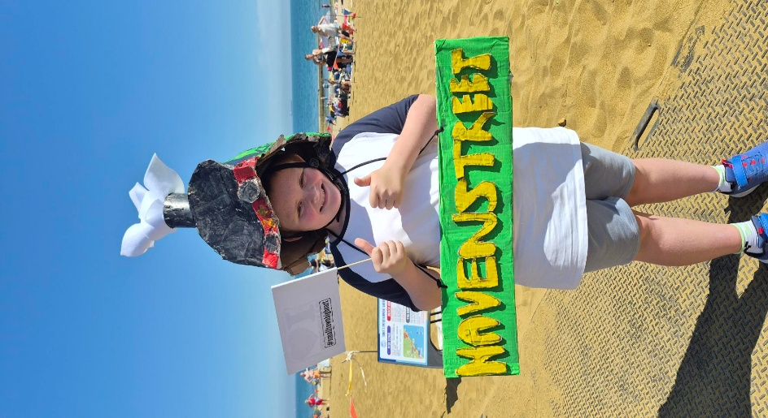
Oliver proudly displays his Isle of Wight Steam Railway-inspired hat, created for the Sandown Regatta Hat Competition and inspired by his passion for trains and his favourite place on the island, Havenstreet.

The annual Sandown Regatta Hat Competition is known for encouraging imaginative and colourful designs, and Oliver's entry certainly captures that spirit. By incorporating elements inspired by the Havenstreet railway, he has created a hat that reflects both his creativity and his personal interests.
Oliver's entry is a wonderful example of how local events can inspire young people to share their passions with the wider community. His steam railway-themed hat not only celebrates a much-loved Isle of Wight attraction but also demonstrates the dedication and enthusiasm he has for trains.
Whatever the outcome of the competition, Oliver has already achieved something special by proudly showcasing his favourite place on the island and sharing his love of railways with visitors and fellow competitors alike.

